SME and Entrepreneurship Summit APEC 2019
Santiago, November 14, 2019
Preliminary work plan
- Context

During the week of November 11, 2019, the APEC Economic Leaders’ Summit will take place in Santiago and in that context two relevant business activities will be carried out, namely,

- APEC SME and Entrepreneurship Summit (November 14, www.smesummit2019.com)

- APEC CEO Summit (November 15 - 16).

Thursday 14 | Friday 15 | Saturday 16 | Sunday 17
SME Summit |  | ABAC Dialogue with Leaders | APEC Economic Leaders’ Summit
 | CEO Summit

- Objective

The APEC Business Advisory Council (ABAC) is organizing the SME and Entrepreneurship Summit as a high level event with an inclusion seal, providing a participation platform for the smaller business as relevant as the CEO Summit.

ABAC´s Work Plan for 2019 has inclusion as a priority theme and seeks to position the democratization of opportunities that technology enables, regional integration and economic openness as key factors capable of enhancing the activity of SMEs and entrepreneurs.

According to Chile’s export promotion agency (ProChile), only 20% of Chilean companies are qualified to export and only a small fraction among them actually do. A number of asymmetries between Big Business and SMEs, such as access to finance, means to deal with entry barriers, and ability to attract talent, among others, put SMEs at a disadvantage. These only deepen differences between large and small businesses. We believe that facilitating and strengthening SMEs’ performance allows for better distribution of economic prosperity, increases general wellbeing and improves social cohesion.

This SME and Entrepreneurship Summit aims at tackling some of the issues considered strategic for SMEs and entrepreneurs, such as ways to improve regulation and reducing tax costs, increasing access to funding and facilitating digital transition and adaptation to Industry 4.0.

Regional Activities Plan

To ensure that this event contributes to the inclusion of smaller businesses and does not only cater to the ‘elite’ we have planned trips to different cities within Chile. The tour will take place between May and October of 2019 and the main purpose is meeting with different business sectors, academics and entrepreneurs, to let them know about our activities and invite them to participate in the SME and Entrepreneurship Summit in November. We will also encourage them to download an app we have especially designed, that will provide information about next year’s APEC activities. This also includes a platform for online registration to the SME Summit, and access to the list of attendees in order to encourage networking.

- Summit

Date: November 14, 2019

Participation: 800 – 1,000 attendees from APEC economies

Foreigners: 20% (estimate)

Characteristics: High level speakers;
Panels;
Pitch rounds between CEOs and SMEs and entrepreneurship representatives;
Space for a fair with 50 stands of 3x2mt.

Venue: Santiago Business & Conference Center, Santiago, Chile.

Invitation: Through sponsoring companies and trade associations.

Speakers: Founder of Waze, Mr. Uri Levine (confirmed) and others to be defined, aspiring to attract national and international individuals, leveraging the visit to Chile of C-level representatives as participants of the CEO Summit.

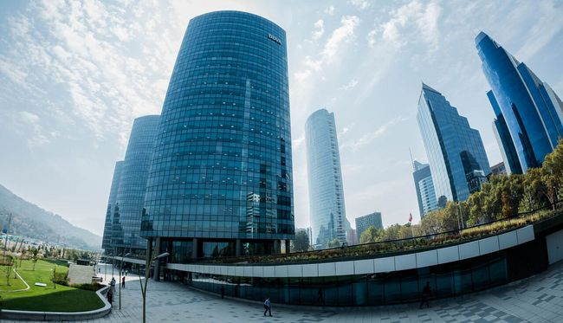

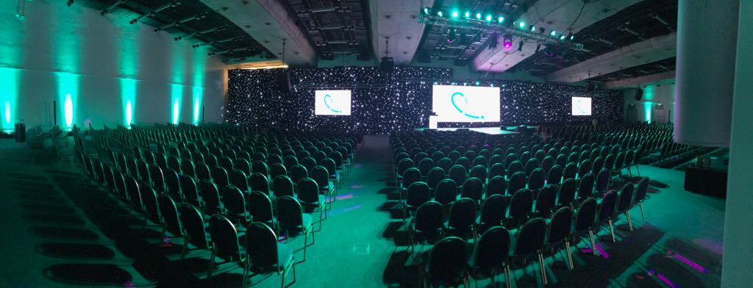

- Summit Contents and Preliminary Structure

Fair with 50 stands and business round  (enterprises to be selected)  Launch of the APEC Monde B2B Platform for SMES and entrepreneurs | Workshops with relevant topics for SMEs and entrepreneurs and  Pitch rounds (8min. dialogue between CEO and SMEs and entrepreneurs)

CATEGORIES OF SPONSORSHIP

PLATINUM sponsorship US $ 100,000 plus VAT
Benefits:
- Free assistance for 20 executives or guests of your company
- Exclusivity in the field
- Promotional stand (3 x 2) in a preferential place in the exhibition area
- Delivery of promotional material to participating entrepreneurs
- Inclusion of the logo in all the graphic pieces in a preferential place
- Inclusion of logo in the press release
- Presence of brand in press conferences
- Presence of brand in the application of the Summit, which will be available from January 2019 and will accompany all the events that take place during the year to promote the Summit (it includes activities in cities of all the regions of Chile).
- Presence of brand in Coffee Break
- Authorization to be known as a "Platinum" collaborator of the event
- Presence of logo throughout the advertising campaign of the event through the media partners.
- Special report with list of participants.

GOLD sponsorship US $ 50,000 plus VAT
Benefits:
- Free assistance for 10 executives or guests of your company
- Promotional stand (2,5 x 2) in the exhibition area
- Delivery of promotional material to participating entrepreneurs
- Inclusion of the logo in all the graphic pieces
- Inclusion of logo in the press release
- Presence of brand in press conferences
- Presence of brand in Coffee Break
- Authorization to be known as special collaborator of the event
- Presence of logo throughout the advertising campaign of the event through the media partners.

COPPER sponsorship US $ 30,000 plus VAT
Benefits:
- Free assistance for 5 executives or guests of your company
- Inclusion of the logo in all the graphic pieces
- Inclusion of logo in the press release
- Presence of brand in press conferences
- Presence of brand in Coffee Break
- Authorization to be known as collaborator of the event
- Presence of logo throughout the advertising campaign of the event through the media partners.

